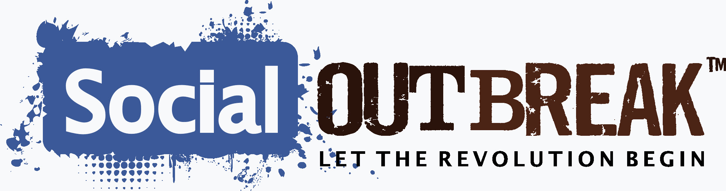

Ted Robbins, Co-Founder and V.P. Social Outbreak Corp

Ted Robbins is a co-founder of Social Outbreak Corp and has been a high level executive, entrepreneur and consultant since 1988. He is an information technology and entrepreneurial professional whose 20+ years experience and multi-disciplinary skills include strategic analysis of emerging technology and markets (with emphasis in social networking and collaborative applications), telephony applications, training and e-learning, proprietary application development, and commercial website/portal design for usability.

Harry Aston, Co-Founder, Director of Social Outbreak Corp

Harry Aston is a skilled executive and recognized entrepreneur whose 30 + years of business experience have given him the opportunity to found and operate successful businesses. He recognizes that his greatest achievements are not what can be said about him, but are the events and people for which he can be thankful. He is an expert in managing strategic development leading to company steady growth that is supported by his vision, mission and passion, resulting in outstanding customer service.

Richard E. LaPorte, Co-Founder, Director of Social Outbreak Corp

Richard is a co-founder of Social Outbreak Corp who is well known as a serial entrepreneur who thrives on finding people or emerging companies with unique products, services and opportunities, and assisting them in financial success. He has a diverse background in small business ownership, public relations, sales, and e-commerce marketing and development. Having had the opportunity to work as the VP of International Expansion in the network marketing industry, Richard has developed long term business relationships both nationally and internationally.

Scott Arvin, President and CEO of Social Outbreak Corp
As CEO and President of Social Outbreak Corp, Scott Arvin is responsible for leading the corporate management team and overseeing all facets of the business. He brings more than 30 years of diversified and proven executive track experience in sales and business management and has been recognized by his peers as one of the top communicators and marketing professionals in the networking industry. Prior to joining Social Outbreak Corp, Scott developed and hosted an Internet radio program, “The Scott Arvin Show”, where he used his creative communication skills and social media expertise to educate and promote the success of home-based entrepreneurs. After joining Social Outbreak as the CEO, Scott became so excited about the company’s prospects that he also became an investor and owner in the company. Scott and his executive management team are impassioned about introducing their revolutionary social networking technology to a global audience of online entrepreneurs.
Kevin Bowser, Director of Operations
Kevin Bowser brings to Social Outbreak Corp a wealth of experience in business operations and software development and management. As an executive sales professional he has a proven record of success in meeting corporate objectives by using strategic, conceptual and solution based techniques. Kevin is also technically proficient with various software systems, merchant accounts and podcasting. His years of experience in sales have left him skilled in the acquisition and retention of customers due to his ability to build positive customer relationships while providing outstanding customer service. Kevin has a BS from North Carolina Central University and served as a Lieutenant in the US Navy.
Renee K. LaPorte, Director of Fiscal Management (Interim) and Treasurer
In the course of a diverse 33 year career in all aspects of business and health care consulting and management, Renee has proven to be a skilled executive manager, trouble-shooter and turnaround expert. She has worked in a variety of business and management settings, primarily specializing in the healthcare arena, serving in the roles of COO and CEO. She has developed and managed a successful professional case management company in Michigan for 20 + years. An RN by training, she has an MSA in Business Management from Central Michigan University, and a PhD in Philosophy of Natural Health.
Paula Presley, Director of Customer and IBO Services
Paula Presley is an accomplished entrepreneurial executive who knows that leading by example and building and retaining successful relationships is vital for business and professional growth. She has proven leadership expertise having managed her own travel agency as well as working in the fast paced cellular industry with both customers and distributors alike. Paula has a love for people and a passion to help others succeed in business and in life.

